Week 3 Attendance Analysis
Project Title: Campus Cultural Fest Operations Dashboard & Process Optimization System
Prepared By: Karthick Raja
Objective
The objective of this analysis is to evaluate participant attendance during the cultural fest and measure the difference between registrations and actual participation.
Attendance analysis helps event organizers understand participant engagement and improve planning for future events.
Attendance Data Analysis
SQL Query Used,
SELECT
Attendance_Status,
COUNT(*) AS Count
FROM Attendance
GROUP BY Attendance_Status;

Query Result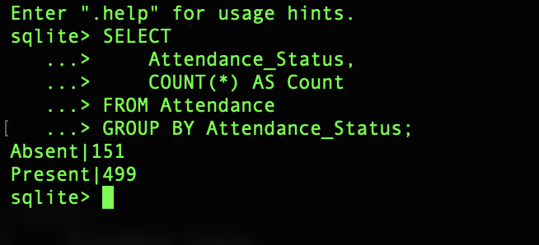
Attendance Summary
Attendance Status | Participants
Present | 499
Absent | 151
Total Registrations | 650
KPI Calculation
Attendance Rate
Formula:
Attendance Rate = Present Participants ÷ Total Registrations × 100
Calculation:
499 ÷ 650 × 100 = 76.77%
Result:
Attendance Rate = 76.77%

Absentee Rate
Formula:
Absent Participants ÷ Total Registrations × 100
Calculation:
151 ÷ 650 × 100 = 23.23%
Result:
Absentee Rate = 23.23%
Key Findings
Finding 1: Strong Participant Engagement
- Out of 650 registered participants, 499 attended the cultural fest.
- This indicates a good level of participant engagement.
Finding 2: Attendance Target Achieved
- The project KPI target was Attendance Rate > 75%
Actual attendance rate: 76.77%
- The attendance target was successfully achieved.
Finding 3: Registration Drop-Off Exists
- A total of 151 registered participants did not attend.
This represents 23.23% of all registrations. Although expected in large events, reducing absenteeism could improve event participation levels.
Visualization
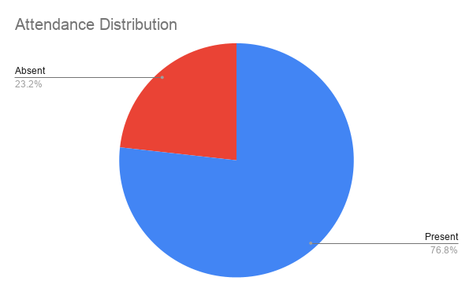

Business Impact
Attendance directly affects:
- Venue utilization
- Volunteer planning
- Event scheduling
- Budget allocation
- Resource management
Understanding attendance patterns helps event organizers estimate future participation more accurately.
Recommendations
Recommendation 1
Send reminder emails or messages one day before the event. This may help reduce absenteeism.
Recommendation 2
Implement event check-in confirmations. Confirmed attendees are more likely to participate.
Recommendation 3
Monitor registration-to-attendance trends across future events to improve attendance forecasting.
Insight Summary
Metric | Value
Total Registrations | 650
Total Attendance | 499
Attendance Rate | 76.77%
Absentee Rate | 23.23%
KPI Target Met | Yes
Conclusion
The attendance analysis showed that 499 out of 650 registered participants attended the cultural fest, resulting in an attendance rate of 76.77%.
The attendance target was successfully achieved, indicating strong participant engagement. However, 23.23% of registered participants did not attend, suggesting opportunities for improving communication and participant follow-up in future events.

